# 20 Internet of ThingS(IOT) Applications:

1. **Predictive maintenance:**

[Maintenance](https://research.aimultiple.com/predictive-maintenance/) is conducted to prevent predicted problems. So over the lifetime of a machine, some components may never be checked if they are not predicted to cause problems. For example, [Fanuc](https://www.fanuc.eu/es/en/lifetime-management/maintenance-services) is a robotics company that is working on reducing the downtime of machines with IoT technology. Fanuc uses sensors to predict when the failure of the component will happen. Predictive maintenance Maintenance is conducted to prevent predicted problems. So over the lifetime of a machine, some components may never be checked if they are not predicted to cause problems.

1. **Industrial process automation/optimization**

Organizations can keep a real-time record of the metrics of all the machines inside a plant using IoT and IP networks. Manufacturers can use this data to automate workflows and to optimize production systems. Automation and optimization support industrial companies to reduce costs and increase the quality and volume of output. The [market](https://www.statista.com/statistics/728530/industrial-robot-market-size-worldwide/) for automated industrial robots is proliferating. The market size was 41 billion U.S. dollars in 2017 and is expected to reach 73 billion U.S. dollars in 2023.

1. **Energy Management**

Energy can be a costly input for industrial businesses. With fluctuating energy costs and strict government requirements of efficiency, managing energy distribution becomes important. IoT devices can help manufacturers manage energy consumption based on real-time data collected from devices. Intelligent energy management systems reduce energy bills, operational expenditures and carbon footprint of the factory while increasing energy efficiency. [WebNMS](https://www.webnms.com/iot/energy-management.html" \t "_blank) is an [IoT platform](https://research.aimultiple.com/iot-platform/" \t "_blank) that provides IoT applications including energy management to optimize the energy consumption of businesses.

1. **Outdoor surveillance**

When IoT CCTV cameras combined with [artificial intelligence](https://research.aimultiple.com/ai/) and [machine vision](https://research.aimultiple.com/machine-vision/), governments can automate surveillance of streets through cameras. As IoT enables connectivity of machines, they are able to record and analyse video data in real time, and they can provide police officers with insights instead of single pieces of images. However, outdoor surveillance processes personal information and there is potential for abuse in use of such technologies. Therefore appropriate checks and balances need to be implemented in such systems to ensure that personal information is not abused while risk of crime is minimized.

1. **Smart lighting**

According to the 2018 [Gartner](https://www.gartner.com/doc/3883066/hype-cycle-internet-things-) IoT hype cycle report, smart lighting is the fourth-most mature IoT tech application. Smart lighting aims to optimize energy management. Smart lighting is made up of street lighting with IoT sensors. Sensors collect data about the condition of traffic and pedestrians. With that data, street lights provide optimum lighting so that street lighting systems can save up to 80% of the energy. Smart lighting can also be applied to factories or homes.

1. **Electronic Road Toll Collection and Traffic Management**

Traffic engineers augmented by smart systems at a central traffic management center (TMC) can analyze data from IoT sensors then optimize timing of traffic lights throughout the day. This can help divide the traffic more evenly over roads as traffic volume fluctuates.

1. **Smart parking**

In cities like San Francisco, parking is a big problem. With IoT sensors, parking problems in a city can be minimized.

Working principle of smart parking is:

1. Sensors are attached to parking lots to detect parked cars
2. Measurements are periodically sent to the cloud by microcontrollers
3. Mobile Apps use cloud data to identify empty parking spaces,
4. Drivers check mobile apps to identify vacant parking spaces close to the location they aim to go to.

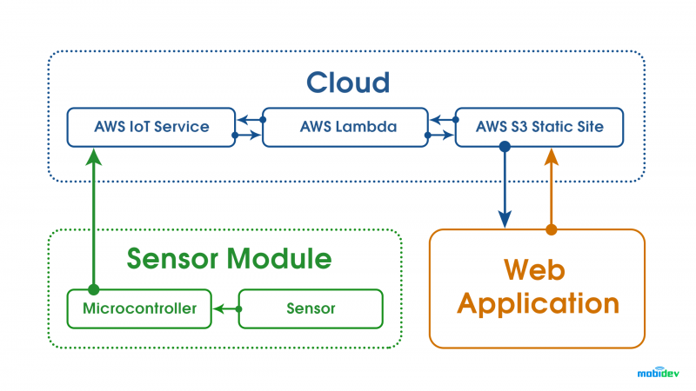

1. **Noise Monitoring**

In smart cities, sound monitoring systems can monitor noise levels and warn companies that violate limits and help manage noise levels.

1. **Structural Health Monitoring**

IoT allows remote collection of architectural data to monitor events such as vibrations and changes in material conditions, predict structural damage, and prepare action plans for structures such as bridges, buildings, stadiums, ships, airplanes, etc.

1. **Waste Management**

Traditional waste collections are complicated and costly since a fleet of trucks drives along busy streets using inefficient routes. Fill levels of garbage containers differ for each container: ranging from overflowing, partially filled and empty. IoT sensors can monitor fill levels for conventional bins and send the data to the relevant department of the city hall. With that information, the garbage truck routes can be optimized for trash collection.

1. **Water Management**

Due to the drastic increase in urbanization levels and the importance of water quality in human health, water management is a key topic for cities. A water management system is based on real-time data collected from sensors. Water management can provide the following applications:

**Water conservation**

Sensors detect the water level in tanks and alerts when the water level is lower than the threshold. [Well™,](https://mindtribe.com/2017/03/well-a-smart-home-water-conservation-system/) a smart home water conservation system developed by [Mindtribe](https://mindtribe.com/selected-work/" \t "_blank), uses IoT sensors to monitor water usage.

**Smart Irrigation**

IoT sensors determine the weather condition and the soil moisture, which will help in getting the appropriate amount of water that soil needs. [Bosch](https://www.bosch.com/stories/iot-based-smart-irrigation-system/) offers an IoT solution that measures how much water the tree needs and provides that amount of water.

**Leakage Management**

IoT sensors can detect temperature changes, water leakage, chemical leakage, and pressure level in water tanks.

**Water Quality Management**

IoT sensors determine what kind of chemicals are in the water. They also identify metrics such as total dissolved solids (TDS), bacteria, chlorine, electrical conductivity, etc.

1. **Digital Health**
2. Ultraviolet Radiation Monitoring
3. Sunlight consists of three major components:
4. Visible light: Wavelengths between 0.4 and 0.8 micrometers,
5. Ultraviolet light: Wavelengths shorter than 0.4 micrometers,
6. Infrared light: Wavelengths longer than 0.8 micrometers.

Ultraviolet (UV) rays are electromagnetic waves that account for about [10](https://ag.tennessee.edu/solar/Pages/What%20Is%20Solar%20Energy/Sunlight.aspx)% of solar light. When overexposed, UV rays have harmful [effects](https://www.epa.gov/sunsafety/health-effects-uv-radiation) such as skin cancer, premature aging, cataracts, and immune system suppression. IoT sensors measure UV sun rays to warn people not to be exposed in certain hours.

**Smart Retail**

1. **Supply Chain Control**

IoT devices have transformed supply chain management. Sensors, which are attached to storage containers or to products themselves, show the location of goods using GPS, track the speed of movement providing an accurate estimated time of arrival (ETA) for goods, monitor warehouse conditions such as temperature, humidity, light intensity, and other environmental factors

1. **Near Field Communication (NFC) Payment**

NFC enables contactless payments. POS vendors include NFC support in their systems, and customers are adopting contactless payments via their smartphones.

1. **Layout Optimization**

Sensors in the store collect data like voice, image or video to better understand customer habits and preferences. Retailers can get insights to redesign the layout of their stores. The optimized layout can enhance sales.

1. **Smart Product Management**

IoT sensors enable retailers to control the rotation of products on shelves and warehouses to automate merchandising decisions. We have already written about [retail analytics use cases,](https://research.aimultiple.com/retail-analytics-use-cases/) feel free to check it out if you want to learn more.

1. **Smart Workplace**

**Sociometric badges**

Sociometric sensors are wearable IoT devices that measure the amount of face-to-face interaction, conversational time, physical proximity to other people, and physical activity levels using social signals derived from vocal features, body motion, and relative location. For example, [Humanyze](https://www.humanyze.com/) is a vendor that uses sociometric sensors to perform people analytics. The company helps organizations understand how their teams interact to increase performance.

1. **Smart Homes**

**Remote Control Appliances**

IoT powered home appliances let residents remotely switch on and off devices using smartphone apps to avoid incidents and save energy. Additionally, these devices can make autonomous decisions based on sensor inputs such as preparing fresh coffee when a resident is identified to wake up. Other examples of autonomous or remote controlled actions include: turning on lights, starting the coffee maker, setting temperature, open up a music playlist, locking doors.

**Home Intrusion Detection Systems:**

IoT based home security applications give users capabilities such as smart locks and security cameras that detect motions and send alerts to their smartphones so that they can monitor the safety conditions of their home from anywhere.

1. **Smart locks**

[Eyelock](https://www.eyelock.com/) is a security provider vendor that offers its clients an iris-based authentication solution.

**Motion detection**

[Manything](https://manything.com/) is another vendor in IoT based home security market. It streams homes/office videos and lets users receive alerts when it detects any activity.

1. **Smart Logistics**

**Fleet Tracking**

IoT fleet tracking systems improve security and provide precise and complete reports that give the fleet managers full transparency towards the fleet’s activities. Through GPS monitoring and geo-location tools, companies can track the location of their trucks, optimize routes and monitor their fleet utilization in detail. For instance, Canadian delivery service Sure Track Courier [saved](https://business.bell.ca/web/Shop/resources/pdf/Voice/Sure_Track_Mobility_Case_Study_EN.PDF) 6-10% per month on fuel costs by optimizing routes using IoT data from trucks.

**Platooning**

Platooning involves a group of self-driving trucks that follow a lead truck at high speed safely and efficiently. Trucks use IoT sensors so that each truck communicates with the other trucks to adapt its speed and braking accordingly.

**Connected Vehicles**

Sensors are enhancing vehicles along with AI and analytical capabilities. These sensors provide communication with the driver to supply useful information about other cars on the road and roadside infrastructure to the driver to help the driver make safer or more informed decisions. For example, these vehicles provide GPS enabled location detection feature that helps them detect traffic congestions.

[Autonomous vehicles](https://research.aimultiple.com/aut/) are also an application of IoT devices. Though it is not commonly used in logistics yet, we will witness this approach soon. For instance, [Mercedes-Benz](https://www.mercedes-benz.com/en/innovation/autonomous/the-long-haul-truck-of-the-future/) prototype of the semi-autonomous truck is scheduled for release in 2025.

Hence, Due to the rapid growth in the smart applications in every sector, IoT can take over the major part of the electronics operations by 2030.

Thankyou,

Supreeth Avula

19R11A0499-Ece-2C.